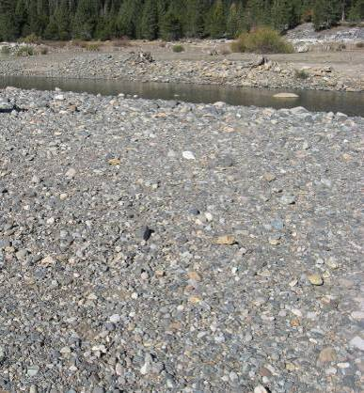 | 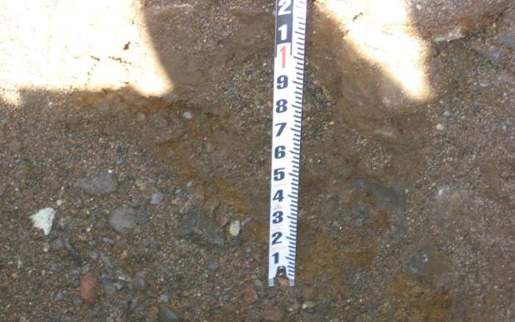
Photos 1 and 2. Particle size composition and bulk sediment sampling in French Meadows Reservoir, Particle Size Region 17. Surface material (left) and subsurface material (right).
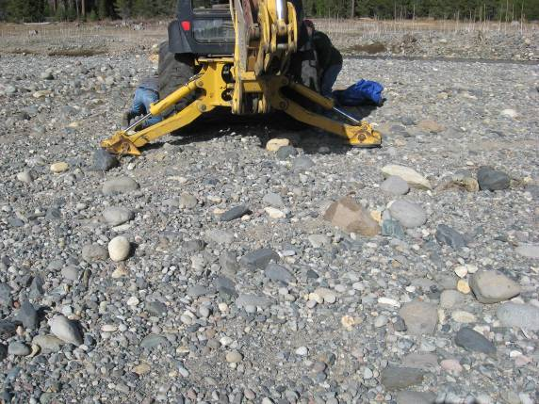 | 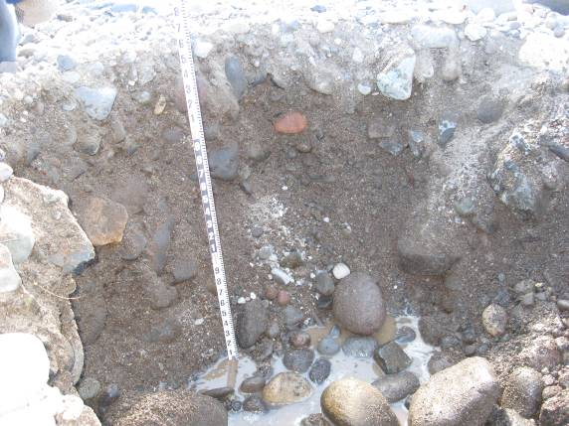
Photos 3 and 4. Particle size composition and bulk sediment sampling in French Meadows Reservoir, Particle Size Region 6. Surface material (left) and subsurface profile (right).
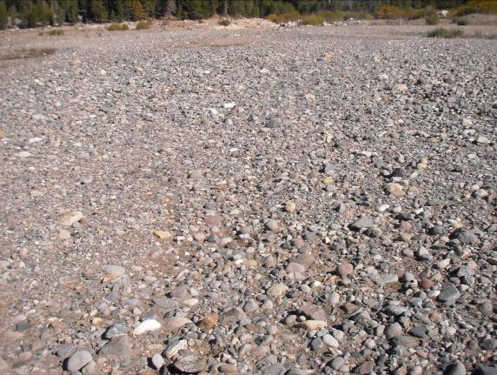 |  | 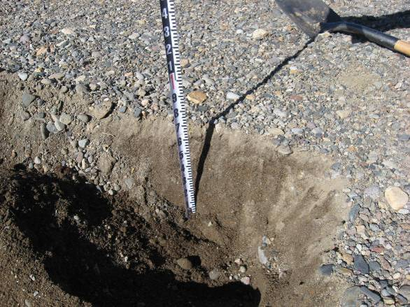
Photos 5 and 6. Particle size composition and bulk sediment sampling in French Meadows Reservoir, Particle Size Region 4, duplicate sample. Surface material (left) and subsurface profile (right).
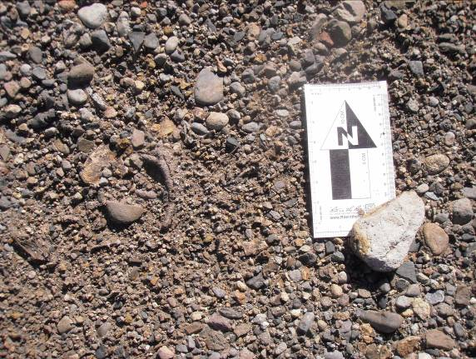 |  | 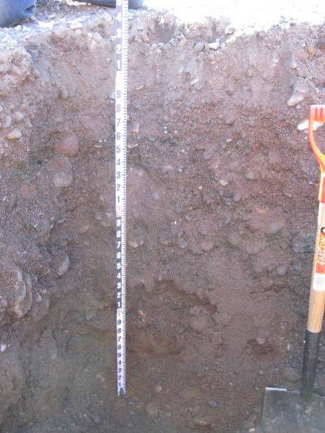
Photos 7 and 8. Particle size composition and bulk sediment sampling in French Meadows Reservoir, Particle Size Region 4, duplicate sample. Surface material (left) and subsurface profile (right).
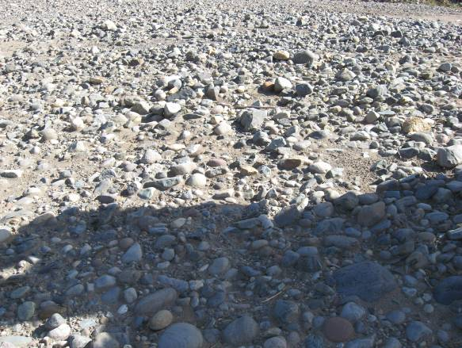 |  | 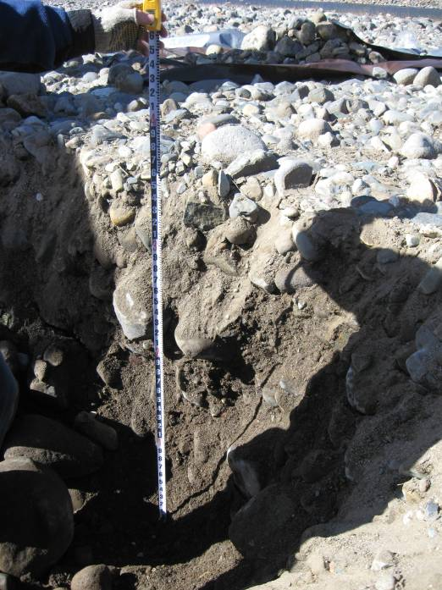
Photos 9 and 10. Particle size composition and bulk sediment sampling in French Meadows Reservoir, Particle Size Region 3. Surface material (left) and subsurface profile (right).
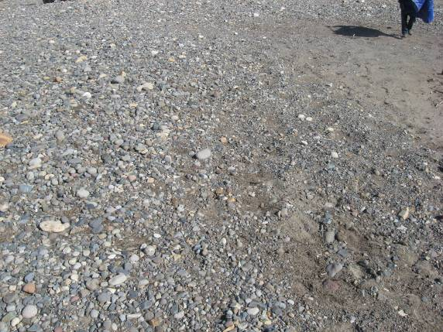 |  |  | 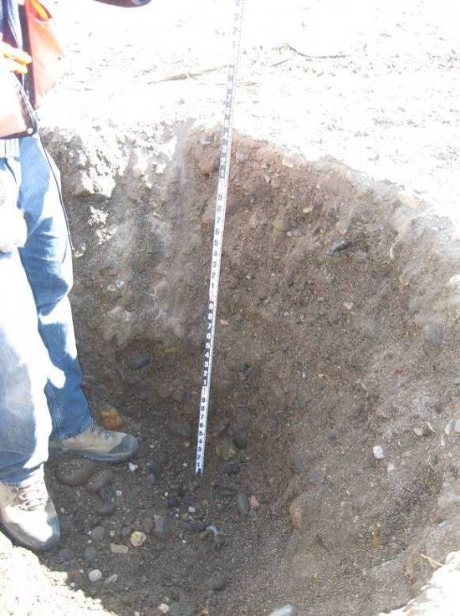
Photos 11 and 12. Particle size composition and bulk sediment sampling in French Meadows Reservoir, Particle Size Region 15. Surface material (left) and subsurface profile (right).
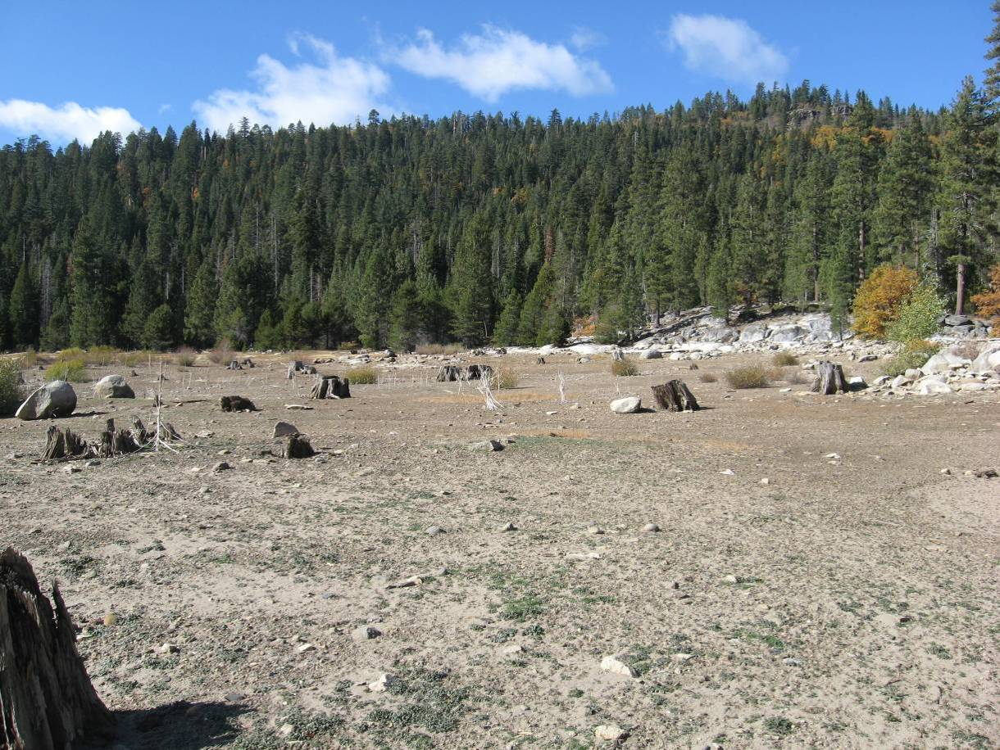
Tree Stumps
Photo 13. French Meadows Reservoir view along north side of low-flow channel. Evidence of tree stumps at grade with ground indicating near original ground surface elevation.
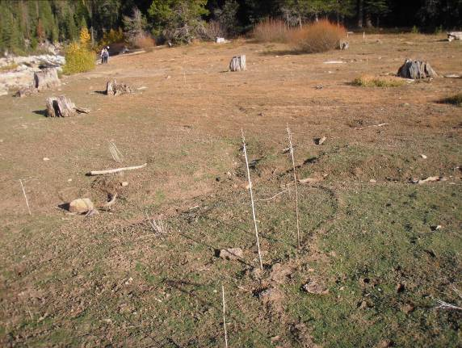
Photo 14. Particle Size Region 23. Sand dominated surface material with evidence of original ground surface, as noted by the exposed tree trunks.
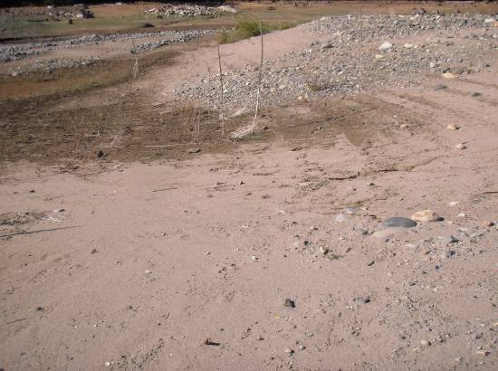
Photo 15. Particle Size Region 10. Sand dominated surface material with small pockets of coarser material.
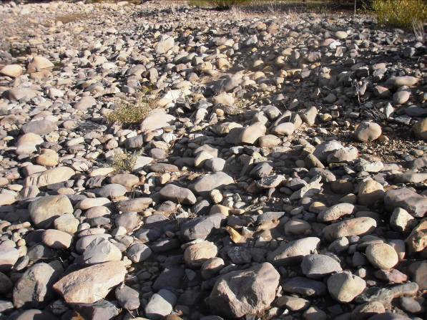
Photo 16. Particle Size Region 24. Cobble and boulder dominated surface material.
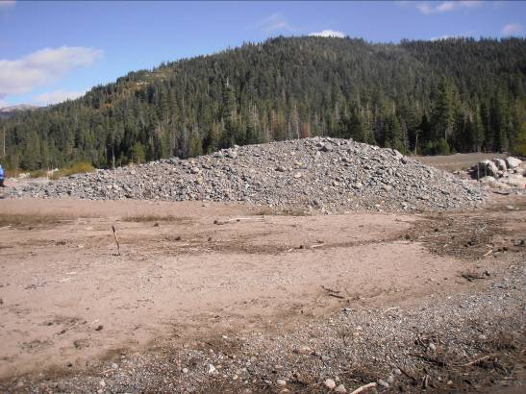
Photo 17. Particle Size Region 11. Depicting a large mound of deposited sediment within the exposed reservoir bed.

